**Module 6-6(Accessing and Modifying Mule Messages)**

**Use an expression to set the payload**

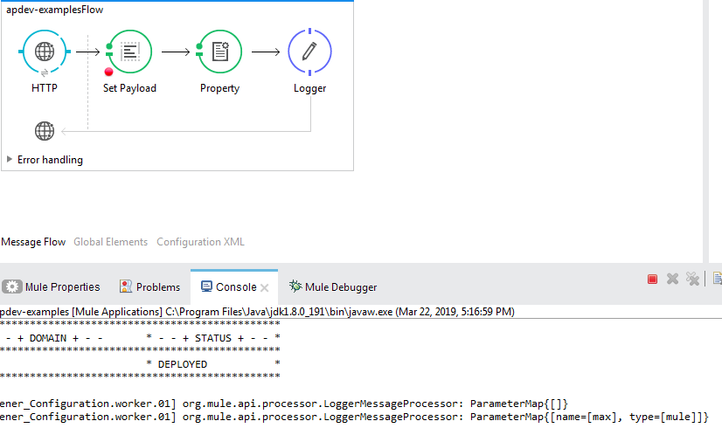

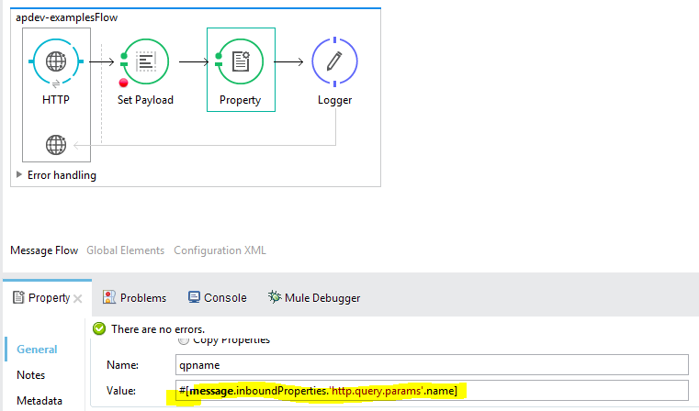

**Output:**



**Read and write variables**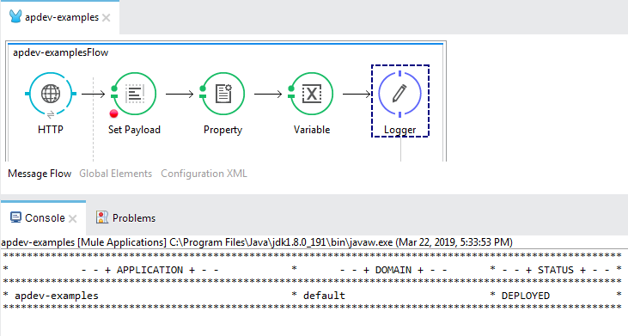

**Adding variable can see in DEBUG mode (variable) tab:**

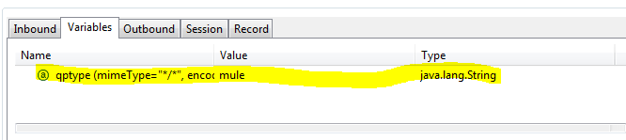

**Output:**

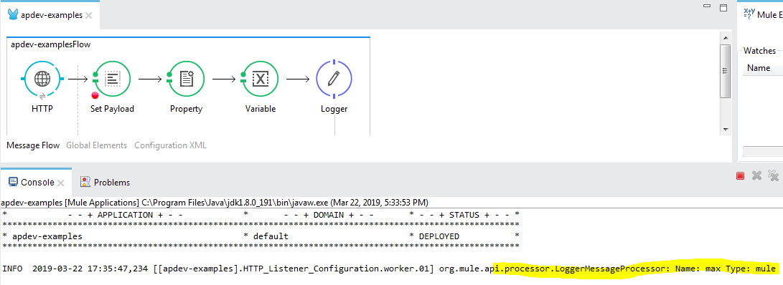

**Session variable creation:**

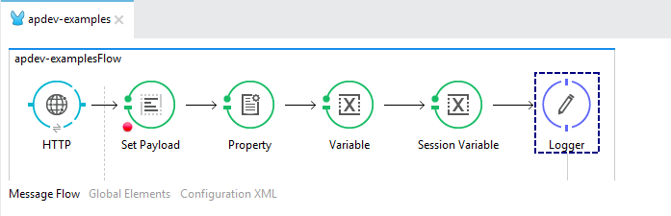

**Session variable:**

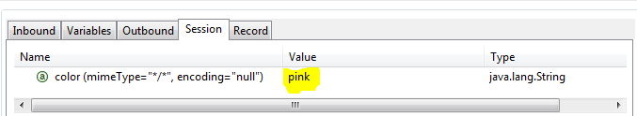

**Output:**

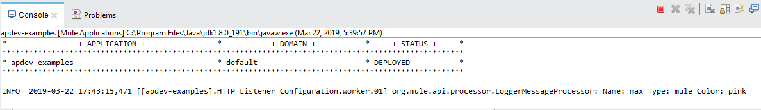

Module 7: Structuring Mule Applications

**Create and reference flows and subflows:**

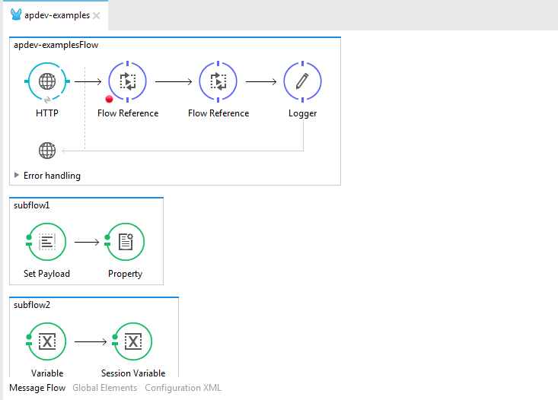

**Output:**

